**Assignment 1 of iOS Bootcamp**

**Ques1. Explain what is Xcode?**

**Ans.** Xcode is an IDE which is developed by Apple and used by the developers to develop software for macOS, iOS, iPadOS, watchOS, and tvOS.

**Ques2. Explain how you can add frameworks in Xcode project?**

**Ans. In this first we have to click on framework as shown below**

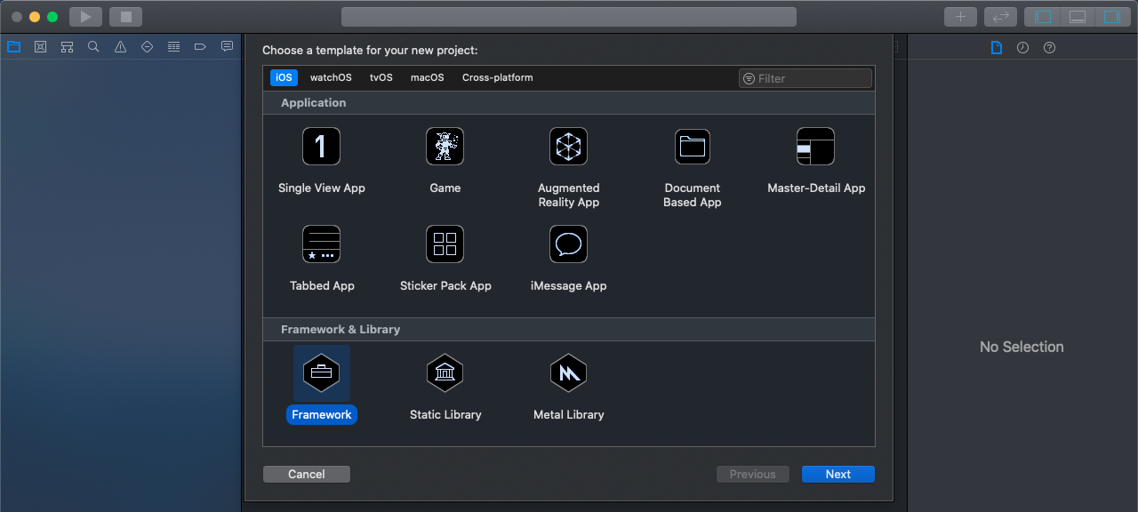

**The framework name is Framework1**

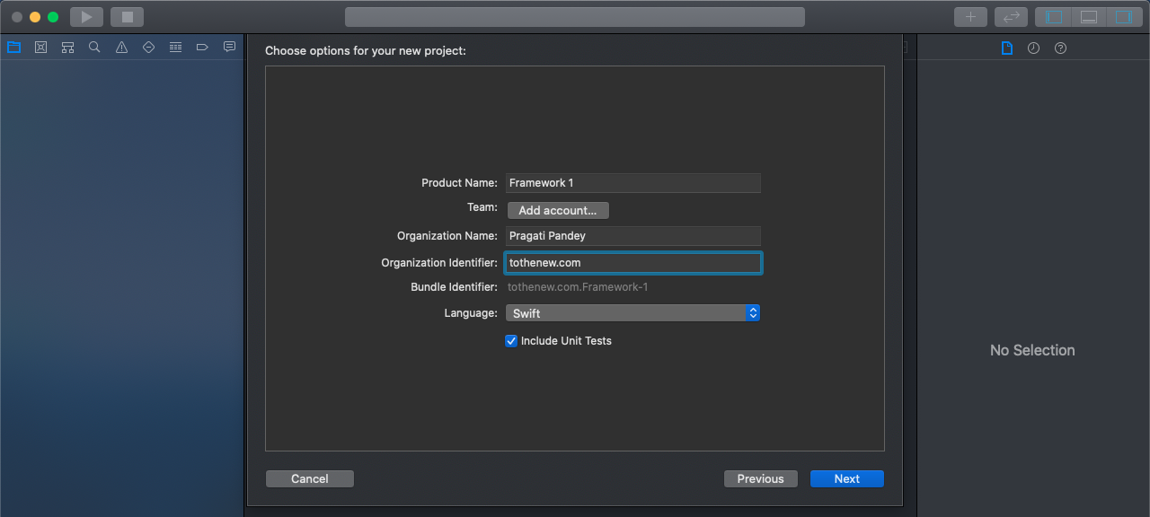

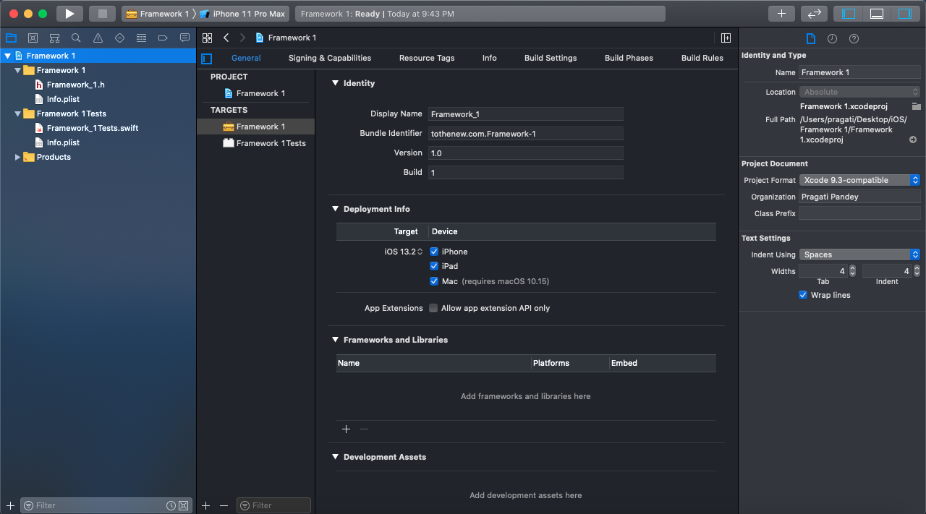

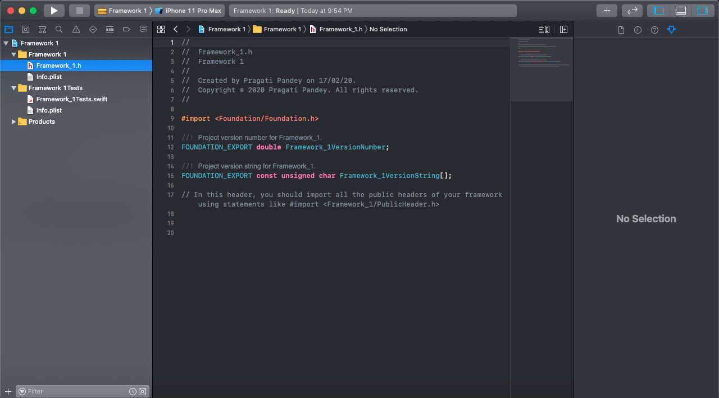

**Now after creating a framework create one project**

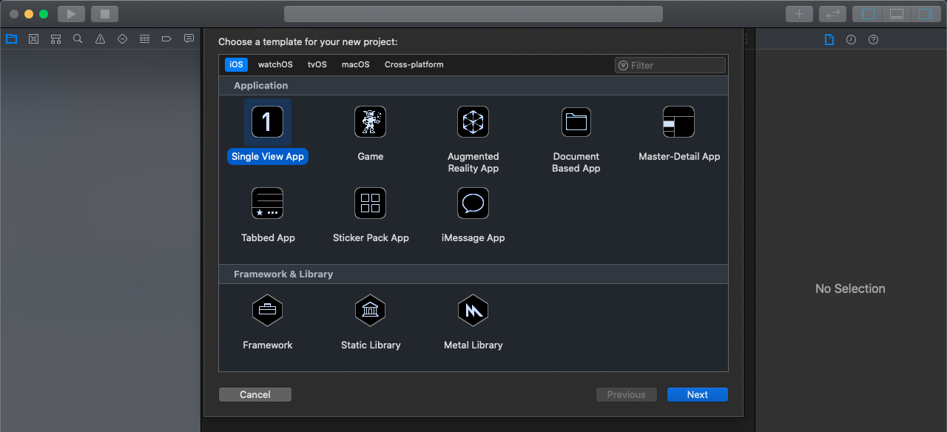

**Here project name is FrameProduct**

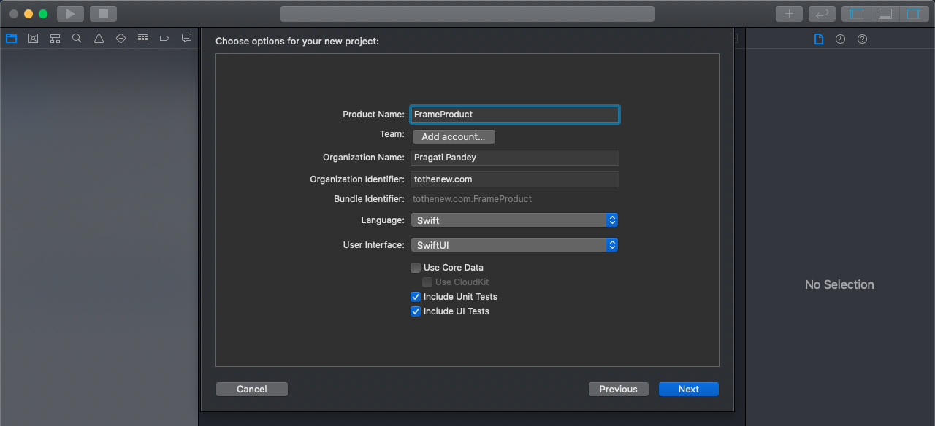

**After creating a project we will add framework in the project by just drag that folder and drop that folder in the project**

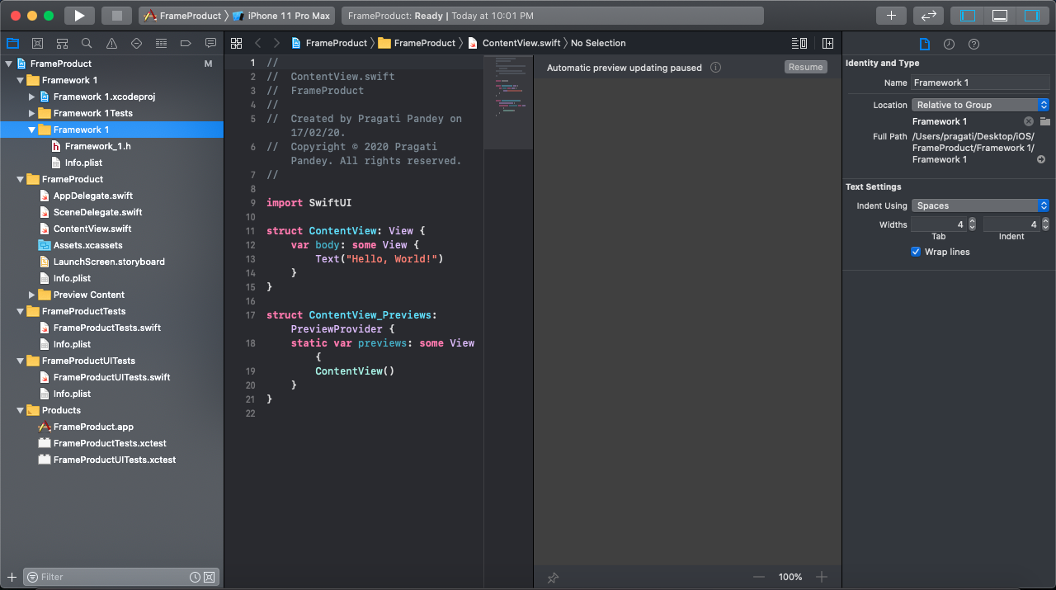

**Ques3. Explain what is the difference between Xcode, Cocoa and Objective C?**

**Ans. Xcode:-**Xcode is an IDE which is developed by Apple and used by the developers to develop software for macOS, iOS, iPadOS, watchOS, and tvOS.

**Coca:-**Coca is a powerful API used for building Mac and iOS applications.

**Objective C:-**Objective C is the language that is used to write applications for the Mac and iOS platforms.

**Ques4. What is the shortcut to open the “Code Snippet Library” in Xcode?**

**Ans.(Shift+Cmd+L)** is the shortcut to open the “Code Snippet Library” in Xcode.

**Ques5. Mention what are the build phases available in Xcode?**

**Ans.** The various types of build phases available in Xcode are:-

1. Dependencies
2. Compile Sources
3. Link Binary with Libraries
4. Copy Bundle Resources

**Ques6. Explain how app delegate is declared by Xcode project templates?**

**Ans.** App delegate is defined as a sub-class of UIResponder by Xcode project templates.

**Ques7. Explain how you define variables in Swift language?**

**Ans.**We define variables in Swift language in the two format:- **var variable name:type=expression**

**var variablename=expression**

**Eg:-** var name:string=”Charles”

Var str=”Charles”

**Ques 8. What is interface builder?**

**Ans.** The Interface Builder editor within Xcode makes it simple to design a full user interface without writing any code. Simply drag and drop windows, buttons, text fields, and other objects onto the design canvas to create a functioning user interface.

**Ques9.Create an app with a login interface which should have two text field for email, password where the password is a secure field and a button.**

**Ans.** Refer the github

**Ques10.List devices and their resolutions, screen size has iOS as their OS.**

**Ans.**1.iPhone 4,4s- 640 X 960- 3.5”

2. iPhone 5s, 5c, 5, SE - 640 X 1136- 4”

3. iPhone 8,7,6s,6 - 750 X 1334 - 4.7”

4.iPhone 8+, 6+,6s+, 7+ - 1242 X 2208 - 5.5”

5.iPhone 11,XR - 828 X 1792 - 6.1”

6.iPhone 11 pro,X,XS - 1125 X 2436 - 5,8”

7.iPhone 11 pro max,XS max - 1242 X 2688 - 6.5”

8. iPad Air - 1536 x 2048 - 9.7”

9.iPad Pro - 2048 x 2732 - 12.9”

10.iPad pro - 1668 x 2388 - 11”

11.iPad pro(1st gen) - 1668 x 2224 - 10.5”

12. iPad mini - 1536 x 2048 - 7.9